ESPECIFICACIONES COMPONENTES
PANTALLA OLED: https://www.didacticaselectronicas.com/shop/oled-0-96-am-az-ssd1306-display-oled-0-96-pulgadas-amarillo-azul-24062#attr=
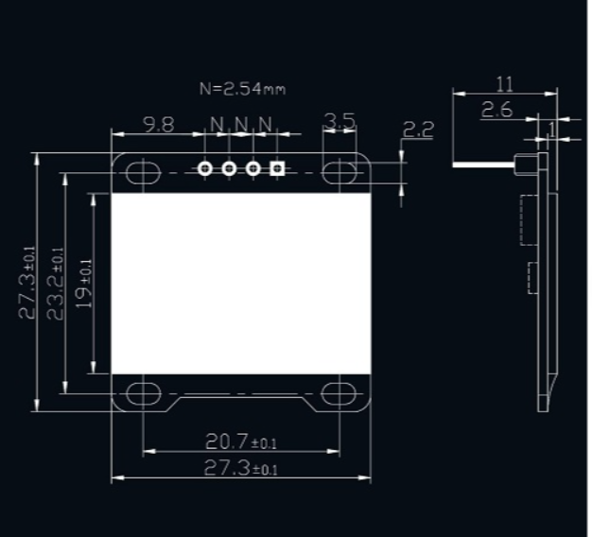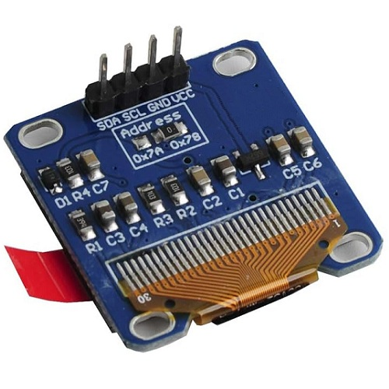

CIRCULO DE LEDS: https://electronilab.co/tienda/anillo-neopixel-16-x-led-rgb-ws2812-5050-drivers-integrados/?srsltid=AfmBOopiC-qj0oLTyqT_qRUx5DKRzjzorMbDG5kra-RAEClp30RQVgjCnlk
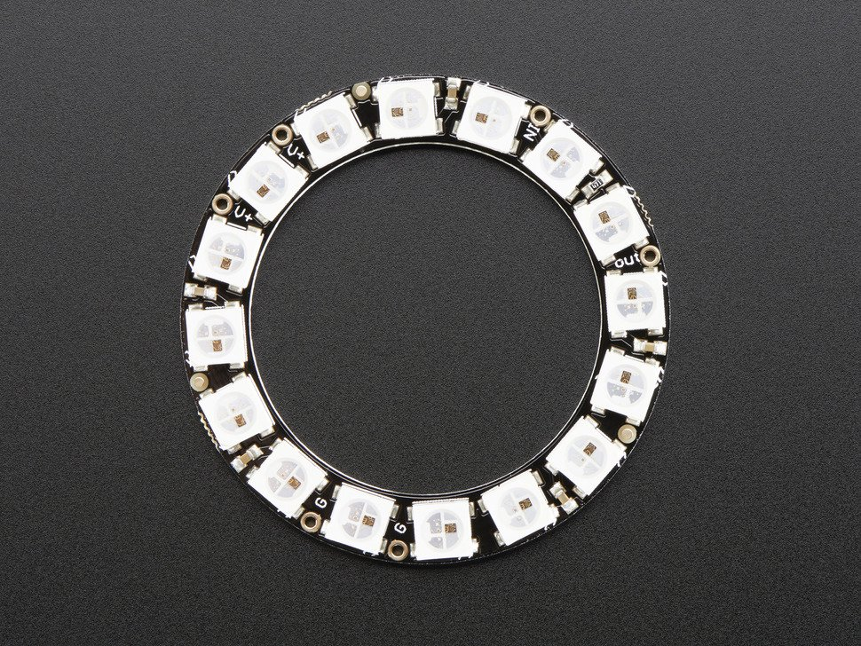
FADERS: 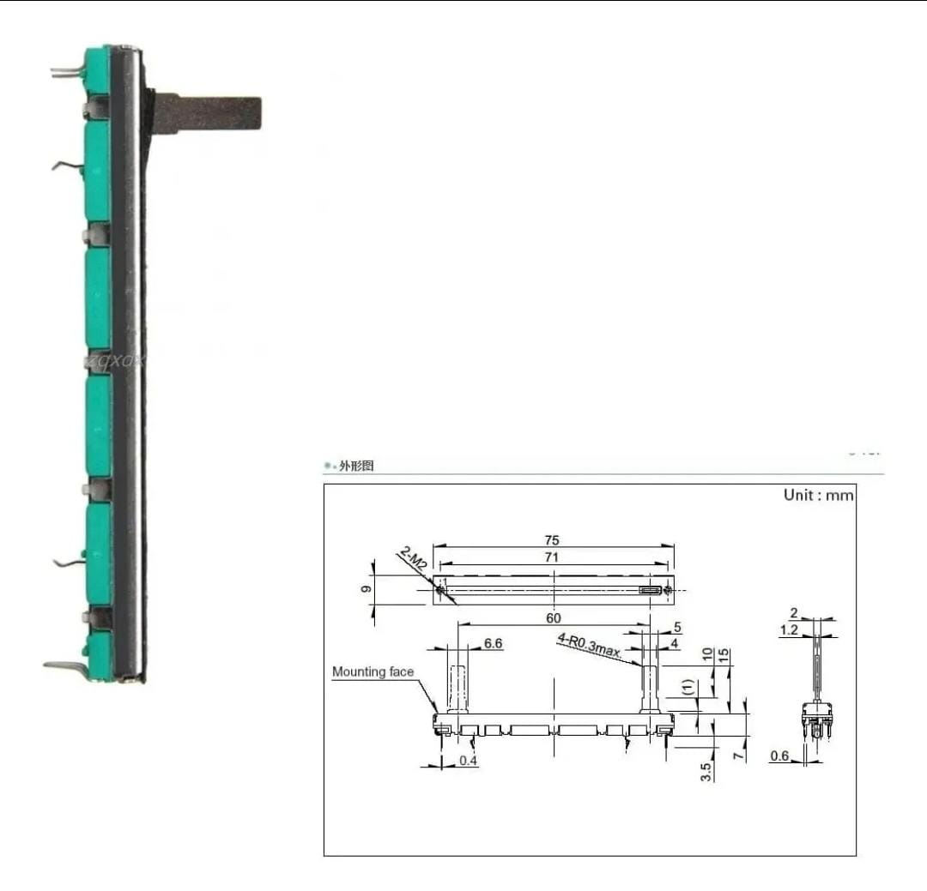
POTENCIOMETRO
https://www.ebay.com/itm/403090550595
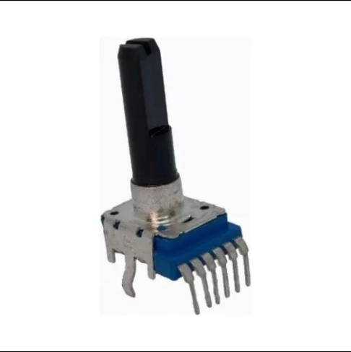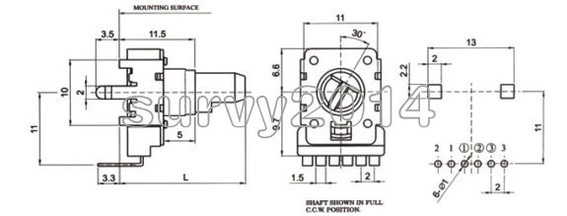

BOTONES ARCADE:
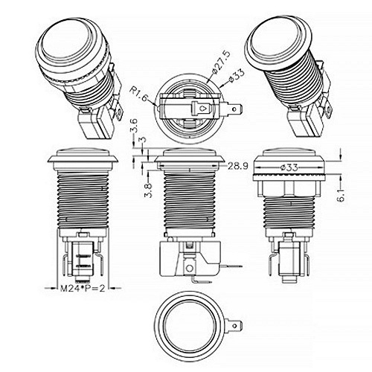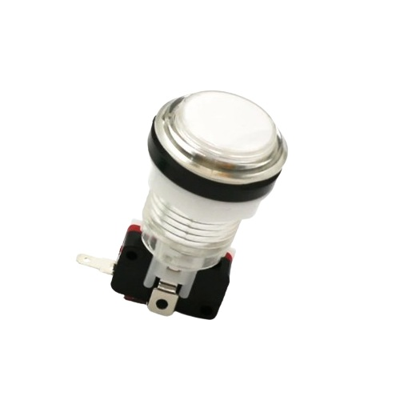
SENSOR ULTRA SONICO:
